EXP.NO:05 | AREA CALCULATOR
DATE:09.08.19 | AREA CALCULATOR
AIM:
To write a Java program to create a “Area Calculator” by creating abstract class named Shape with two integers for finding area of triangle, circle, rectangle.
REQUIREMENT:-
-Abstract class named Shape.
-With two integers and an empty method named printarea().
-Three classes named rectangle, triangle and circle. Where Shape is the super class and all other classes are sub classes
-Each class containing printarea() method that is used to print the area of the given shape.
ALGORITHM:-
STEP 1: start
STEP 2: create the package shapearea, super class shape and sub classes Triangle, Circle, Rectangle and Calculation
STEP 3: In the class Shape declare the attributes a, b which will be used in the sub classes for calculating area
STEP 4: each class is provided with a printarea() method where in the calculation class the respective values for calculating the area will be given
STEP 5: By execution of the program the area of the triangle, circle and rectangle is found out
STEP 6: stop
CLASS DIAGRAM:
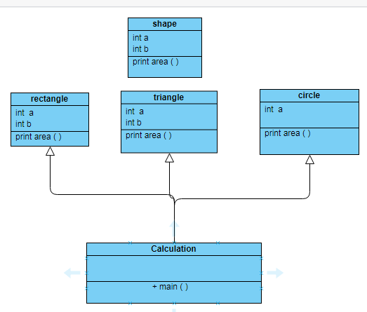

PROGRAM:
/*
* developed by A.sandhiya
* EEE-B
* 212217105052
*
*
*/
package shapearea;
abstract class shape {
protected int a;
protected int b;
abstract public void printarea();
}
package shapearea;
public class circle extends shape {
public circle(int l)
{
super.a=l;
}
public void printarea() {
double area;
area=3.14*super.a*super.a;
System.out.println("the area of the circle is:"+area);
}
}
package shapearea;
public class rectangle extends shape {
public rectangle(int l, int h)
{
super.a=l;
super.b=h;
}
public void printarea() {
double area;
area=super.a*super.b;
System.out.println("the area of the rectangle is:"+area);
}
}
package shapearea;
public class triangle extends shape {
public triangle(int l, int h)
{
super.a=l;
super.b=h;
}
public void printarea() {
double tri;
tri=0.5*super.a*super.b;
System.out.println("the area of the triangle is:"+tri);
}
}
package shapearea;
public class calculation {
public static void main(String[] args) {
shape sha;
sha=new rectangle(50,60);
sha.printarea();
sha=new circle(20);
sha.printarea();
sha=new triangle(40,60);
sha.printarea();
}
}
OUTPUT:
the area of the rectangle is:3000.0
the area of the circle is:1256.0
the area of the triangle is:1200.0

RESULT: Hence, a Java program is created where a “Area Calculator” by creating abstract class named Shape with two integers for finding area of triangle, circle, rectangle is done and the respective area is found out

